**After Effects Tutorial – Video Photomontage Short Story**

**For all video projects it’s crucial that all content (photos, sounds, music, footage, etc.) is located on the C:drive,  
 not the S:, not the Z:, not the H:, but only the C:drive.**

1. The first step in the production process will be placing all your photographs in a folder on your C:drive such as the “Desktop”.
2. You need to have a backup copy of that photo folder in your Z:portfolio in case something happens to the C:.
3. Open Adobe After Effects
4. Create a composition by going to FILE, NEW COMPOSITION.

What is a composition? A composition is the arrangement of visual elements.

1. Click on the BASIC tab and choose the following: preset: NTSC DV, Width:720px, Height:480px, Frame Rate:29.97, **DURATION: 0;00;05;00 – type this in by changing the default from 25 seconds to 5.**

**Start off with all photographs lasting for 5 seconds. You can change the timing easily by dragging the edge of the clips on the timeline or right clicking on them and going to TIME STRETCH to specify an exact duration.**

1. Go to FILE, IMPORT, MULTIPLE FILES and select all your photographs from the C:folder location that you created.

**\*\*\*\* If images need to be resized, right click on it and select TRANSFORM, FIT TO COMPOSITION.**If your images are larger than the stage it’s a good opportunity to do a transformation zoom out or in.

1. Select the first photograph that you want in your video and drag it onto the stage. Place it in the middle of the stage. It should snap to the center of the stage when you hover over the middle.
2. You can drag all your photographs onto the stage simultaneously if you prefer by selecting them all and dragging them to the middle of the stage. They will be in the order that they are in your library so you may want to reorganize them on your timeline but first you need to extend the timeline to last for more than 5 seconds.
3. Go to COMPOSITION, COMPOSITION SETTINGS and change the DURATION to the length that you think your total production will be such as 1 or 2 minutes. You can change this at any time.

To view the exact amount of time for each clip simply right click on the clip and choose TIME STRETCH. To change the time duration of a clip simply change the “NEW DURATION” in the TIME STRETCH window.

To add effects (like filters in Photoshop) right click on a layer and choose EFFECT and your style. You can change the parameters of any effect in the “Effect Controls” panel. You can animate any effect by dropping down the layer properties and then the EFFECTS layer to adjust the individual properties within it.

If the program seems to be running slowly you can adjust the editing quality for faster viewing by changing the setting of the resolution drop down option which is located directly below the main “COMP” window. It’s probably set on “FULL” by default, but the more images, effects, and transformations you have the slower After Effects will render the project.

1. It’s time to add some animated text. Go to the menu bar and select LAYER, NEW, TEXT.
2. Right click it and select RENAME. Type in an appropriate name for what the text will say.
3. Click on the stage to type your message. Go to the “CHARACTER” panel on the right side of the screen to adjust the properties of text. If you don’t see it, go to WINDOW, CHARACTER.
4. After typing your message it’s time to add an animated preset effect. Click on the text layer.
5. Go to the EFFECTS & PRESETS panel on the right side of the screen next to the CHARACTER panel.
6. Drop down ANIMATION PRESETS, then TEXT, then 3D TEXT, then choose one. Press the space bar to play the composition and see the 3d text effect. To preview presets before applying go to next step.
7. You will probably want to browse the presets before applying them to your layers so go to the drop down menu in the EFFECTS & PRESETS panel and choose BROWSE PRESETS. Another program called BRIDGE will open.

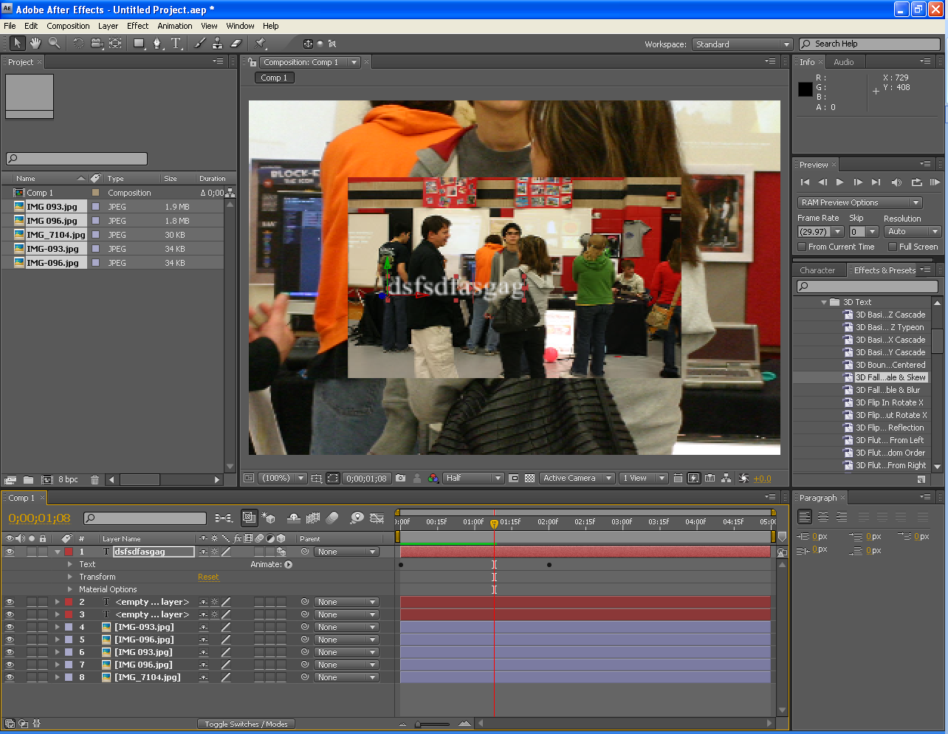

1. Click on each preset to preview the animation style in Bridge before applying.
2. To apply the animation preset you prefer simply doubleclick it (if text or layer is selected)
3. To adjust the properties such as speed or style of the animation click on the triangle on the layer to drop down the additional options such as TEXT, TRANSFORM, etc.



1. To make adjustments to the animation preset you must drop down all layers by clicking on the triangles until the keyframe circles become diamonds. Once you find the layer with the diamonds you change the location of them to increase or decrease the speed by simply dragging them. You can change any property here. You can add additional keyframes and transformations here.

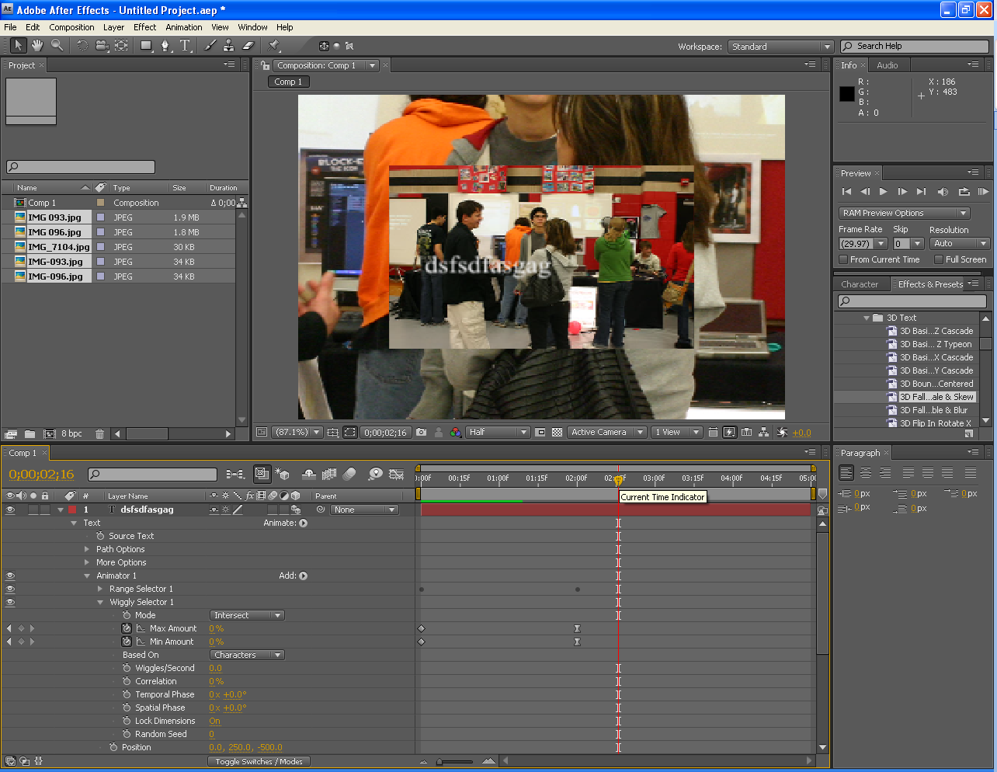

1. It’s time to animate your photographs individually. First you need to swivel the triangle to drop down the layer.
2. Next, drop down the TRANSFORM layer to view the options underneath it.
3. Place the yellow play-head with the red vertical line (marker) where you want the transformation to start.
4. Turn on the stop watches of the properties that you want to apply changes to such as SCALE, POSITION, etc. by clicking on the stopwatch icons.

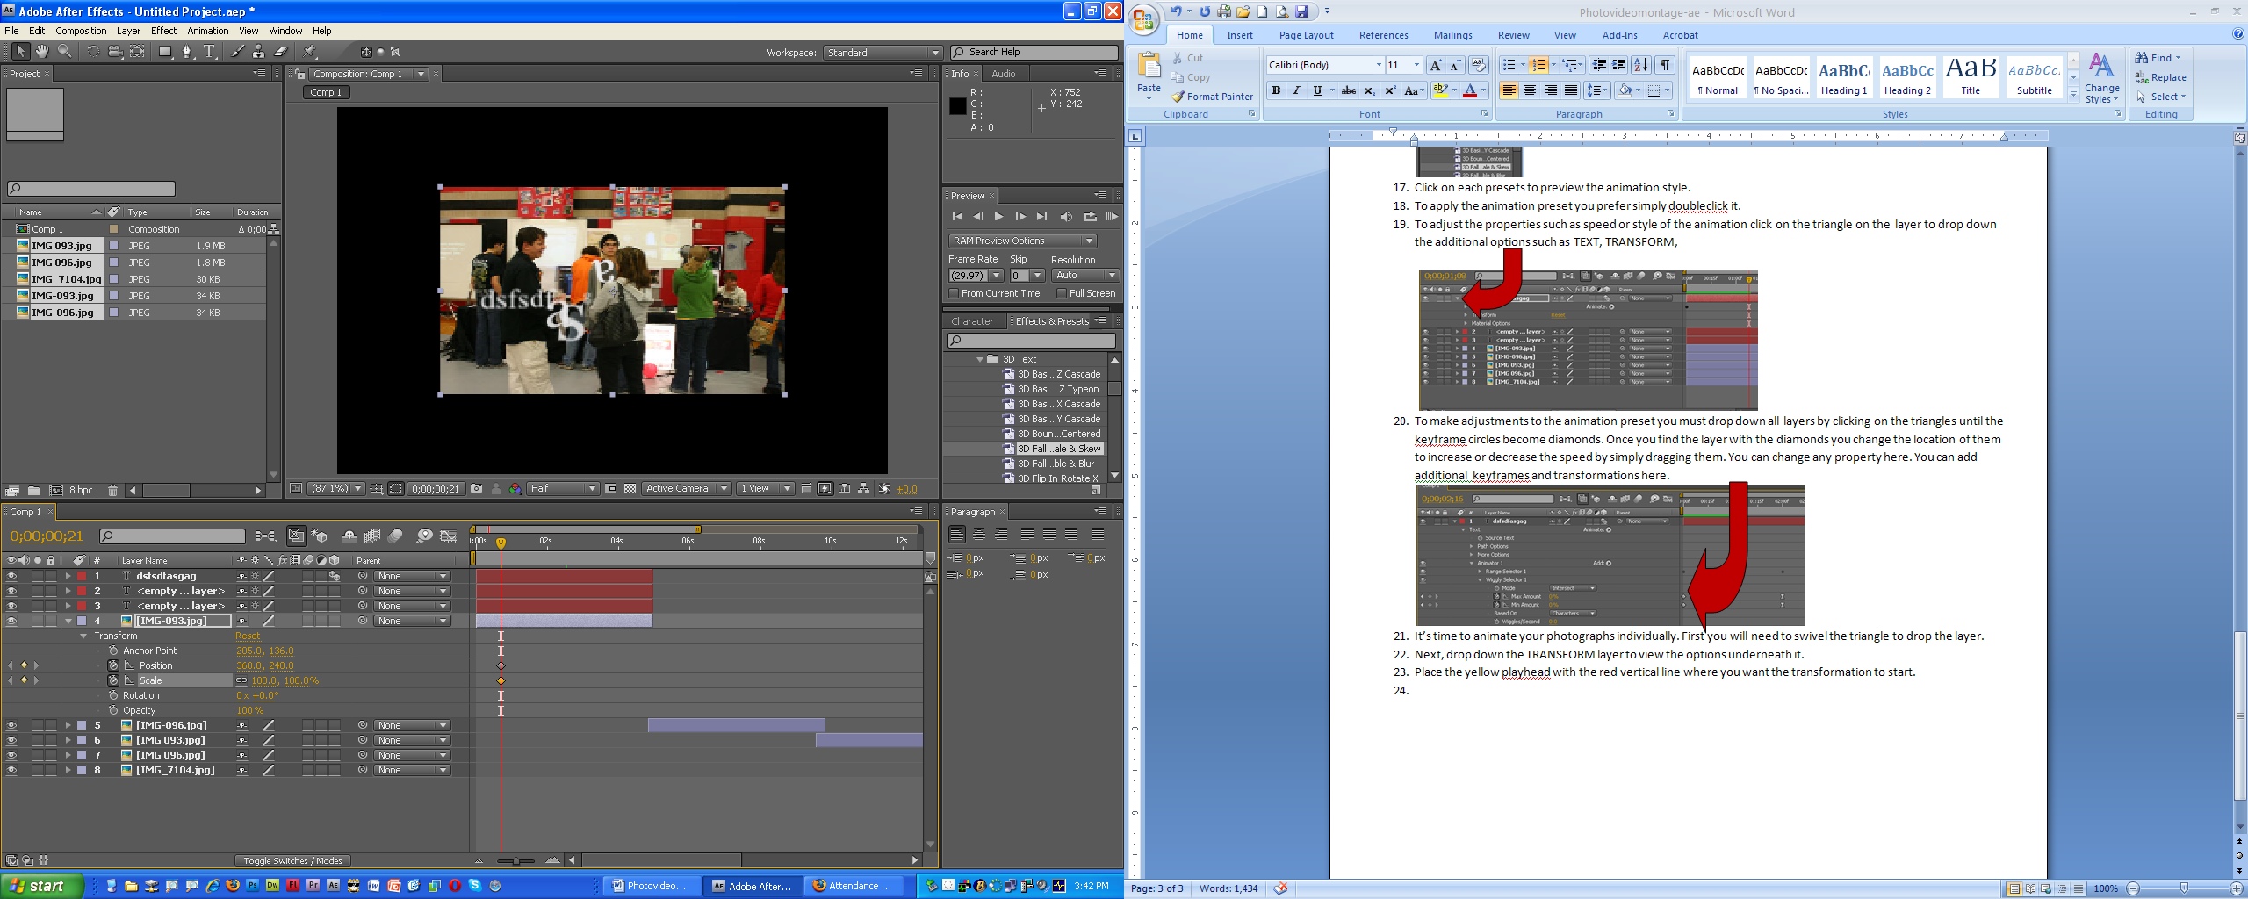

1. Move the play-head where you want the transformation to end and change a parameter of a property that you turned on with the stopwatch. You can slide the parameter number, or type in a new parameter, or click on the photograph and move it to the new location.
2. When completely finished with your short story you will need to render it. Go to FILE, EXPORT, QUICKTIME MOVIE, set compression type to H.264, deselect SOUND if you don’t have any, click OK. SAVE IN: DESKTOP.
3. Once the movie has been rendered to your desktop copy the file to the Z:drive “Photomontage video” folder and your Z:”Portfolio, Finished Projects” folder so you have it at the end of the year on your cd.